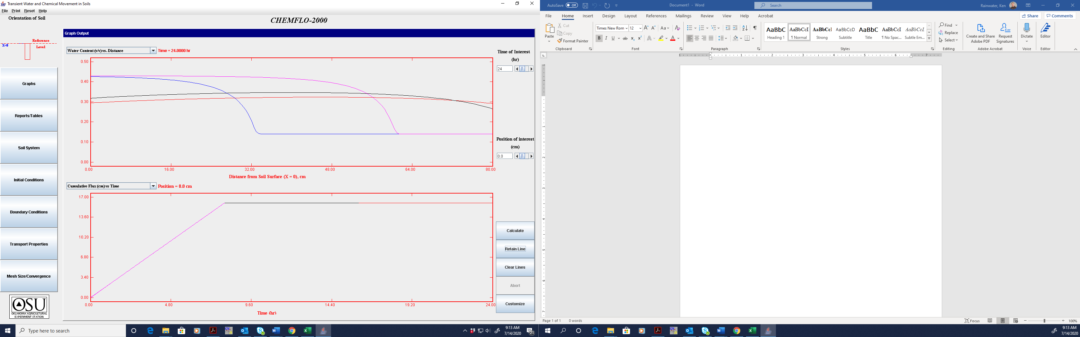

Evidence of completion of example scenario #2

Top graph Water content (v/v) vs. Distance for 4, 8, 12, and 24 hours, four lines on one graph

Bottom graph Cumulative Flux (cm) vs. time at 0.0 cm